**D17 - Eligibility - Academic level justification**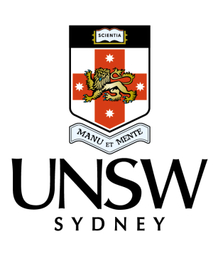

22 November 2017

Professor Sue Thomas

Australian Research Council

GPO Box 2702 CANBERRA ACT 2601

Dear Professor Thomas,

**Future Fellowship Application – Dr Sasha Rubin FT180100410**

UNSW Sydney supports this Future Fellowship application at Level 2 for Dr Sasha Rubin.

Dr Rubin received his PhD from the University of Auckland in 2007 (completed in 2004) and has held a series of postdoctoral fellowship and prestigious visiting fellowships, including a Marie Curie Fellowship. In 2017 Dr Rubin commenced a postdoctoral position with the University of Naples "Federico II". An ARC Future Fellowship at level 2 is appropriate based on his previous academic level, research experience and opportunity. In Australia Dr Rubin’s current academic level would be equivalent to a level C. As such, Dr Rubin’s current position and salary level aligns most closely to a Level 2 ARC Future Fellowship.

Dr Rubin is at an established mid-career stage researcher, he has generously served the scientific community at various levels of responsibility, and has successfully transitioned from junior postdoctoral roles to competitive fellowship and more senior positions.

As such, UNSW endorses Dr Rubin’s Future Fellowship application as appropriate for funding at the indicated salary level.

Yours sincerely,

Nicholas Fisk

Deputy Vice-Chancellor (Research)